IDEA/APPROACH DETAILS:

Ministry Category: Students' Innovations Problem

Statement: SOFTWARE (DEVELOPING AN EFFECTIVE E-COMMERECE MARKETINGPLACE TO BRIDGE THE VALUE GAP BETWEEN THE FARMERS-MANUFATURERS-CONSUMERS)

Team Leader: Vedanth Padigelwar

Problem Code: #SIC6

College ID: #9377

**From Seeds of Suicide to Seeds of Hope**

**PROBLEM STATEMENT**: Developing an effective e-commerce marketplace to bridge the value gap between farmers – traders –consumers

Suicide among farmers has been a routine in India for the last 20 years. Nearly 300,000 farmers have ended their lives by ingesting pesticides or by hanging themselves. The suicide rate among Indian farmers had increased by 47 percent, according to a 2011 census in a country where agriculture remains the largest employment sector. The share of agriculture in employment was 48.9 per cent of the workforce in India, but agriculture accounted only for 17% of the GDP. Agriculture's contribution to GDP has steadily declined from 1951 to 2011, yet it is still the country's largest employment source and a significant piece of the overall socio-economic development.

From the above statistics it is very clear that there is a fundamental change required in the current system in agriculture. The rising cost of food in the past years are often blamed on a multi-layered system of middlemen involved in the distribution of produce from farmers to consumers. Over the years, several layers of intermediaries, by lengthening the supply chain declined farmers from the fair income for their produce. India’s poor infrastructure in crop producing regions also contribute to the same.

**OUR SOLUTION**

We will be building a platform that will function as a market place and supply chain.

There are some problems which we have to address to lead to a more effective system compared to our current system.

1. A reliable market place which can act as an interface between farmers and consumers, eliminating any middlemen
2. Absence of proper grading system to know the quality of the material beforehand
3. An effective transportation system
4. A transparent money transaction system
5. Application of algorithms to make the app user friendly

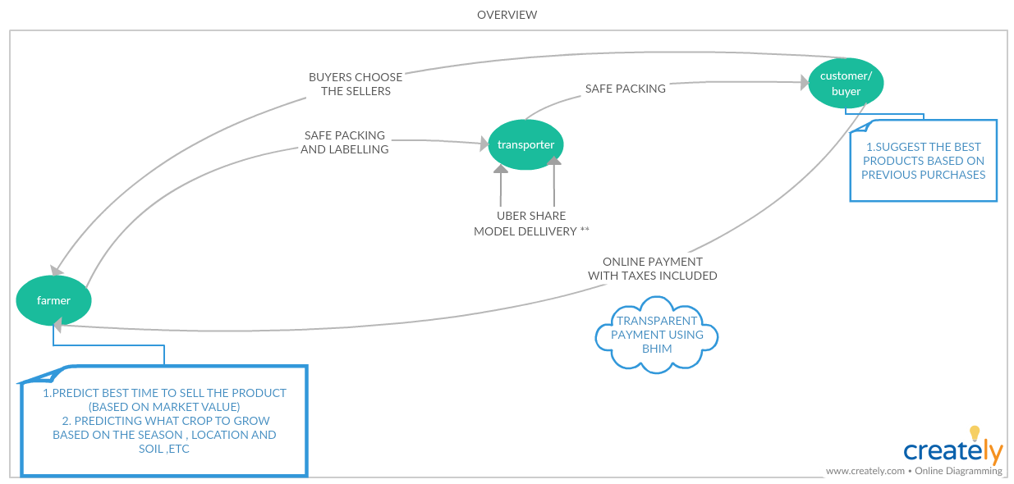

1. **RELIABLE MARKET PLACE**
   1. **FARMER’S POINT OF VIEW**

It all starts with the farmer signing up in the app using his Aadhaar card. As soon as he is registered by linking his Aadhaar Card, he will be shown a couple of questions which includes the soil climate and permission to access to his location. Thus, the app analyzes the maximum potential of his produce using our prediction system.

Once a farmer wants to sell a product he can advertise his product (with price and quantity). In addition to this the farmer will be given suggestions of the optimal crop to grow based the current conditions of the area. Similarly, suggesting them for the best time to sell the product to get maximum profit out of the product

* 1. **CONSUMER’S POINT OF VIEW**

The consumer will be provided with suggestions based on the product purchased previously. Once a consumer searches for a product, the list of available farmers along with the price and the farmer’s rating. The consumer will also be shown a list of logistics according to his need.

This would create an effective marketplace which helps in the interaction between farmers and the consumers thus eliminating any middlemen.

1. **Absence of proper grading system to know the quality of the material beforehand.**

As a general rule, there is hardly any grading of the commodities to be marketed. Therefore, the consumer has little confidence, if any, in the quality of the product(s). This brings us to the second part of building a **multilayer grading system** that is unlike the conventional grading systems which we see in all the existing e-commerce product. The **rating will be based on different aspects** of the products like quality, punctuality, packing of the product, similar rating will be given for the transportation also. Thus, making it easier for the consumer to decide between products.

1. **An effective transportation system**

# BOOKING

In the Uber app, you select Uber Pool and enter your destination. Once you have selected your destination you will see the amount charged for the ride.

If you accept, the request will go to all nearby cab drivers and when one of them accepts the ride. If there is a co-passenger travelling with you, his or her name will also be displayed. However, you can't see where your co-passenger is going.

Same way we can implement it in our transport system. We could transport multiple items in a similar manner. Over here the cab drivers will be the logistic people, passengers will be the items that are being sold from one place to another.

# ALGORITHM

The algorithm dynamically adapts the route, basis the first commuter's pick-up and drop-off point, as the main route and the following bookings are matched accordingly, in real time. The most important objective of the algorithm in Ola share is to make sure that a customer opting for Ola Share does not suffer a delay or deviation beyond a few minutes.

We could implement the same thing for the logistics of this app, and hence reduce the transport cost and supply more goods across the country and thereby helping more farmers in less time. Each Item will be packed in a proper and efficient manner, so that no item will be damaged and misplaced

**A small touch from TECHNOLOGY**

|  |  |  |
| --- | --- | --- |
| **Technology** | **What it does** | **Final outcome** |
| Machine learning (neural networks) | * Predict what crop to grow at a particular time * Predict the best time to sell the crop to get maximum market value * Giving suggestions for the consumers based on his previous purchases | * Help telling at a given time best crop for the soil and the season * Based on previous year’s sales report of the product and market values, to help farmers get the best price |
| Database System | Information of all the farmers, Logistics and the consumers  Stored. | This can be used by government for surveys and  Accountings. |
| Location and Transportation (Uber , Ola algorithm implementation) | The algorithm dynamically adapts the route, basis the first commuter's pick-up and drop-off point, as the main route and the following bookings are matched accordingly, in real time. | The system resulting in effective usage of transportation system |
| App and web | App to provide beautiful front end and web for the back end | App help in reaching out more people and making the interaction easier |
| Digital Payment System | The BHIM app from govt. of India (UPI Based) is great for the payment  system | This will allow to make the payment system transparent and corruption free and foolproof |

FUTURE PLANS:

* Multilingual Support
* Chatbot to help users within the app
* Redesign the User Interface for better cognitive ease

**Technology Stack:**

**Server Side:**

* Operating System
* Database
* Programming Language

**User's Phone:**

* Native Application (Interface)

**FRAMEWORK: LANGUAGE:**

1. Numpy Python

Pycharm

Keras(Neural Nets)

2. Android Studio Java

3. Matlab Matlab

4. Express.JS Node.js

The main intention is to help people connect with farmers directly, eliminating any middle man. Hence, farmers receive their fair share

USE CASE:

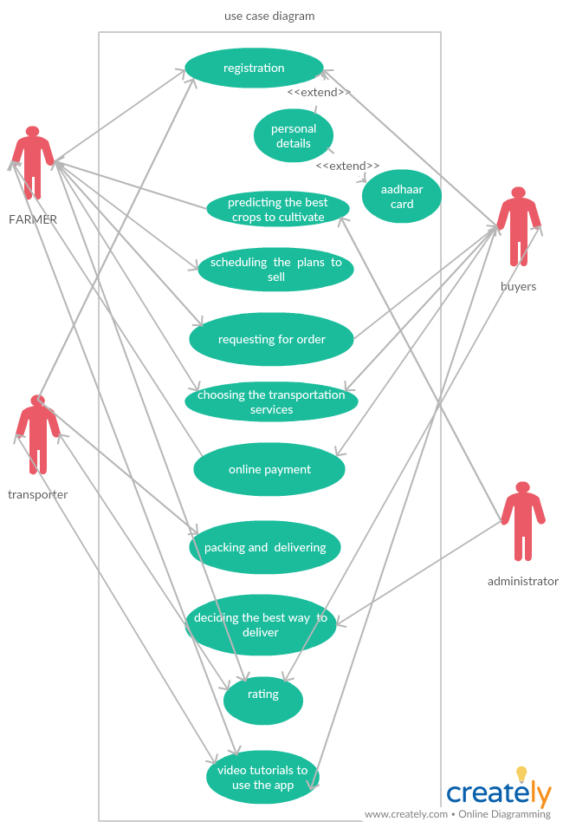

Dependencies and Show Stoppers

Since we predict the time that it is best for the farmers to sell their crops. The problem that occurs is that most farmers don’t have good storage facilities.

The solution we propose is to build Government owned warehouses, where farmers can store their crops in a much efficient way. They could make a society among themselves and manage the warehouses.

The second hurdle that we could face is the fact, that most of the farmers of our country are illiterate, hence they wouldn’t know how to use the app.

The solution we propose for this is, that make the farmers educated about using the app by holding government camps in villages, by radio or television advertisements. Hence the famers would use the app in an effective way.